Predicting Employee Attrition Using Remote Work Productivity and Workplace Factors

GROUP PROJECT
Team Members: Gurpreet Gurpreet Kaur, Badamgarav Battushig
Course: CPSC 5071 – Data Management for Data Science
Instructor: Yueting Chen
Date: 02/27/2026

1. Updated Problem Statement 2
Background of the Attrition Problem 2
Motivation for Adding Productivity Variables 2
Integration Approach (Experience-Level Aggregation) 2
Refined Research Objective 2
2. Data Description 3
2.1 Employee Attrition Dataset 3
2.2 Remote Worker Productivity Dataset 3
3. Data Preprocessing 4
3.1 Data Cleaning 4
3.2 Data Integration 5
3.3 Data Normalization and Feature Engineering 6
4. Preliminary Exploratory Data Analysis (EDA) 6
4.1 Descriptive Statistics 6
4.2 Correlation Analysis 7
4.3 Visualizations 9
5. Preliminary Findings 16
6. Plan for Completion 17
Remaining Data Tasks 17
Modeling Plan 17
Evaluation Plan 17
Timeline 18
7. Git Repository 18
8. References 18

1. Updated Problem Statement

Background of the Attrition Problem
Employee attrition remains a critical issue for organizations because high turnover increases recruitment and training costs, reduces team stability, and affects overall productivity. When experienced employees leave, organizations not only lose talent but also institutional knowledge. Therefore, understanding the factors that influence employee attrition is essential for improving retention strategies and organizational performance.
Traditionally, attrition analysis focuses on HR-related factors such as job satisfaction, salary, overtime, work life balance, job level, and years at the company. These variables help explain workplace conditions that may influence an employee’s decision to stay or leave.

Motivation for Adding Productivity Variables
With the growth of remote and hybrid work environments, productivity related behaviors have become increasingly important. Metrics such as productivity score, daily work hours, task completion rate, late task ratio, and focus time may provide additional insight into employee engagement and performance patterns. These behavioral factors may complement traditional HR variables and provide a more comprehensive understanding of attrition.
Therefore, incorporating productivity metrics allows the analysis to move beyond static HR attributes and include performance based dimensions.

Integration Approach
The attrition dataset and the productivity dataset originate from different sources and do not share matching employee identifiers. Because of this limitation, direct employee level merging is not possible.
To address this issue, productivity variables were aggregated by experience level. Specifically, average productivity metrics were calculated for each experience group. These aggregated values were then merged with the attrition dataset using TotalWorkingYears as the linking variable.
This approach ensures logical consistency by aligning employees with productivity patterns associated with similar experience levels rather than attempting to match unrelated individuals.

Refined Research Objective
After integrating the datasets, the final modeling table combines traditional HR variables with aggregated productivity metrics.
The refined research objective is: To examine how workplace factors and productivity related variables jointly influence employee attrition, and to determine which factors are most strongly associated with employees leaving the organization.

2. Data Description

2.1 Employee Attrition Dataset
The Employee Attrition dataset was obtained from Kaggle: Employee Attrition and Factors – TheDevastator
https://www.kaggle.com/datasets/thedevastator/employee-attrition-and-factors
This dataset contains 1,470 observations and 35 features, representing individual employee level information. The target variable is Attrition, which indicates whether an employee left the company (1 = Yes, 0 = No). This variable is used as the dependent variable in our classification model. Important variables used in this analysis include:
- MonthlyIncome
- JobLevel
- JobSatisfaction
- WorkLifeBalance
- OverTime
- YearsAtCompany
- TotalWorkingYears
- EnvironmentSatisfaction
- MaritalStatus
- Department
These variables represent traditional HR and workplace-related factors that may influence employee turnover.

2.2 Remote Worker Productivity Dataset
The Remote Worker Productivity dataset was also obtained from Kaggle: Remote Worker Productivity Dataset – Ziya07
https://www.kaggle.com/datasets/ziya07/remote-worker-productivity-dataset
This dataset contains multiple observations representing remote workers’ performance and behavioral metrics. Key productivity variables include:
- productivity_score
- stress_level
- average_daily_work_hours
- task_completion_rate
- late_task_ratio
- focus_time_minutes
- experience_years
These variables capture behavioral and performance-based dimensions that may be associated with employee engagement and retention. The productivity dataset does not share employee identifiers with the attrition dataset. Therefore, productivity metrics were aggregated by experience level before integration.

3. Data Preprocessing

3.1 Data Cleaning
Before modeling, several data cleaning steps were performed to ensure data quality and consistency.
First, the dataset was checked for missing values across all variables. After merging the datasets and applying the aggregation approach, the final modeling table did not contain missing values. This ensured that the dataset was complete and ready for analysis.
Second, duplicate records were examined. Any duplicate rows identified in the merged dataset were removed to ensure that each employee was represented only once.
Third, data types were reviewed and corrected where necessary. Categorical variables such as Attrition, Department, JobRole, OverTime, Gender, and MaritalStatus were converted to categorical data types to ensure proper handling during modeling. Numerical variables were verified to remain in appropriate numeric formats.
Next, value ranges were inspected to confirm logical consistency. For example, variables such as JobLevel, WorkLifeBalance, and JobSatisfaction were checked to ensure they fell within expected categorical scales. Salary and experience related variables were also reviewed to confirm reasonable ranges.
Finally, potential outliers were examined, particularly for MonthlyIncome. Extreme values were capped using percentile based trimming to reduce the influence of unusually high or low income values on the model. This step helped improve model stability without removing valid observations.

3.2 Data Integration
The data integration process is a critical component of this project because the two datasets originate from different sources and do not share a common employee identifier.
The Employee Attrition dataset contains individual employee level HR information, while the Remote Worker Productivity dataset contains performance related records for a separate population of workers. Since there is no shared employee ID between the two datasets, a direct row level merge is not possible. Attempting to join the datasets using employee identifiers would result in incorrect matches and invalid analysis.
To address this limitation, productivity metrics were aggregated by experience level. Specifically, the productivity dataset was grouped by experience_years, and the following average metrics were calculated:
- avg_productivity
- avg_daily_hours
- avg_task_completion
- avg_late_ratio
- avg_focus_minutes
This aggregation created one summarized productivity profile for each experience level. Instead of matching individual employees, the integration aligns employees with the average productivity behavior of workers who have similar years of experience.
The aggregated productivity table was then merged with the attrition dataset using:
TotalWorkingYears ↔ experience_years
A LEFT JOIN was used during the merge process. This ensured that all employees from the attrition dataset were retained, even if a corresponding experience level was not present in the productivity dataset.
The number of rows remained consistent before and after the merge, confirming that no employee records were lost during integration. The merge only increased the number of columns by adding aggregated productivity features.
For any unmatched experience levels, missing productivity values were handled by filling them with overall average productivity metrics. This ensured that the final integrated modeling table contained no missing values.
As a result, the final dataset represents an integrated modeling table that combines traditional HR variables with experience level productivity characteristics, allowing for a more comprehensive analysis of employee attrition.

3.3 Data Normalization and Feature Engineering
After data integration and cleaning, several preprocessing steps were applied to prepare the dataset for analysis.
First, the Attrition variable was converted into binary format, where 1 represents employees who left the company and 0 represents employees who stayed. This allowed the variable to be used directly in classification modeling.
Next, categorical variables such as Department, JobRole, OverTime, Gender, MaritalStatus, and EducationField were converted to categorical data types and encoded for modeling purposes. This ensured that non-numeric variables could be properly interpreted by the machine learning algorithm.
Numeric features were standardized using StandardScaler. Since variables such as MonthlyIncome, YearsAtCompany, and the aggregated productivity metrics have different scales, normalization was applied to place them on a comparable range. This step prevents larger scale variables from dominating the model.
Moreover, experience level groups were created from TotalWorkingYears for visualization purposes. These grouped categories helped analyze attrition trends across different career stages, while the original numeric variable was retained for modeling.

4. Preliminary Exploratory Data Analysis (EDA)

4.1 Descriptive Statistics
The overall attrition rate indicates that most employees remained with the company, while a smaller proportion left, showing class imbalance in the dataset.
Key numeric variables such as MonthlyIncome, YearsAtCompany, and TotalWorkingYears show moderate variation across employees. MonthlyIncome displays a wide range, while most employees have relatively lower to mid-level tenure.
The distribution of experience levels indicates that employees are more concentrated in early and mid career stages, with fewer employees in very high experience categories. These initial statistics provide context for understanding patterns observed in the later analysis.

4.2 Correlation Analysis
To further understand relationships between variables, a correlation heatmap was generated including both traditional HR features and aggregated productivity variables.
The heatmap illustrates that most variables have weak to moderate correlations with Attrition, indicating that employee turnover is influenced by multiple factors rather than a single dominant variable.
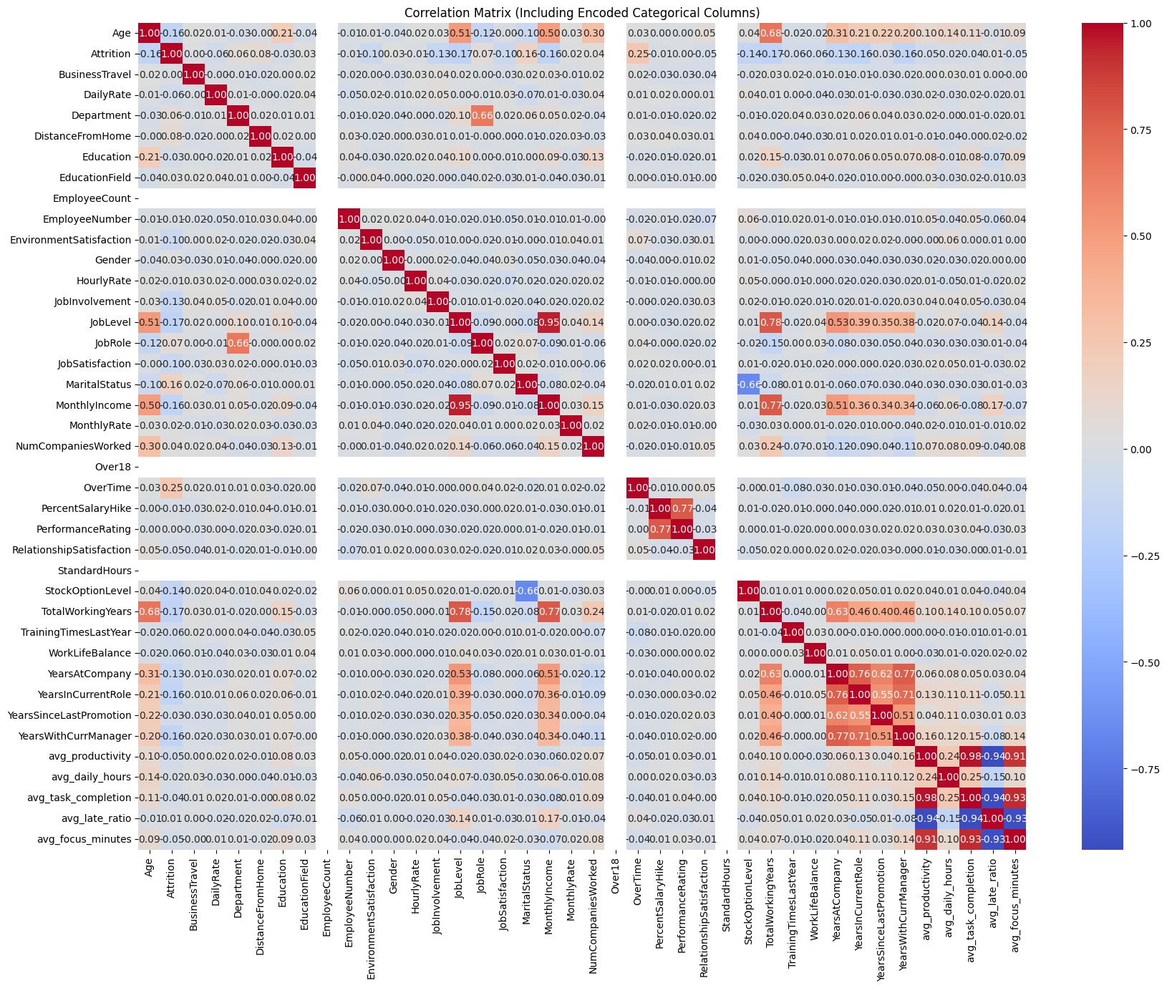
Income vs Attrition
MonthlyIncome shows a negative correlation with Attrition. Employees with lower income tend to leave more frequently, while higher-income employees are more likely to remain with the company. This relationship aligns with earlier boxplot findings.
Overtime vs Attrition
OverTime shows a positive correlation with Attrition. Employees who work overtime appear more likely to leave the organization. This suggests that workload pressure may contribute to higher turnover.
Average Productivity vs Attrition
The aggregated productivity variables (avg_productivity, avg_daily_hours, avg_task_completion, avg_late_ratio, avg_focus_minutes) show relatively weak direct correlations with Attrition. However, these productivity metrics are strongly correlated with each other, indicating that they capture similar performance-related patterns.
Although productivity variables do not individually show strong linear relationships with attrition, they may still contribute to predictive performance when combined with HR variables in the integrated modeling framework.

4.3 Visualizations
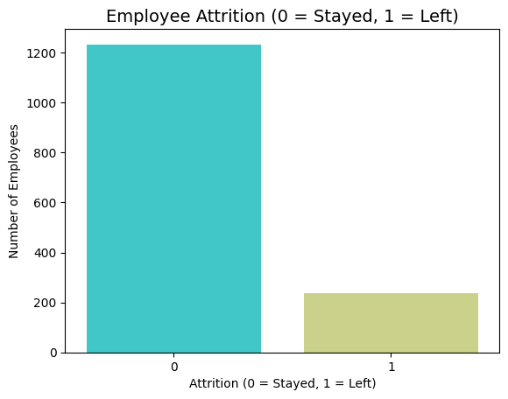
Figure 1 Employee Attrition Distribution
The chart shows that most employees stayed with the company, while a much smaller portion left. Therefore, the dataset is imbalanced, with significantly more non attrition cases than attrition cases.
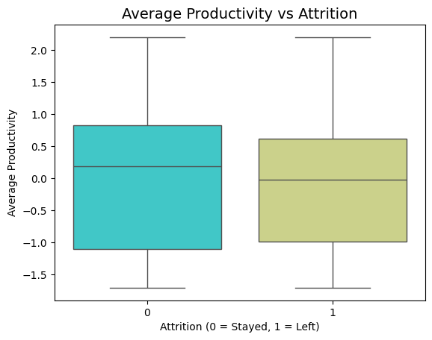
Figure 2 Average Productivity by Employee Attrition Status
Employees who left show slightly lower median productivity compared to those who stayed, although the distributions overlap substantially.
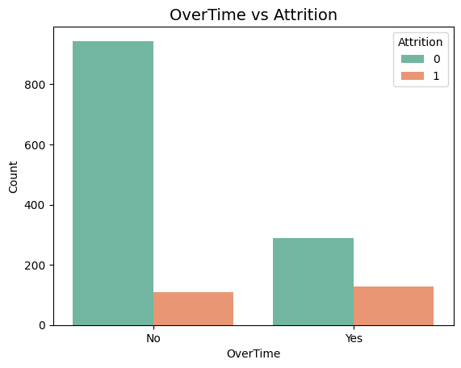
Figure 3 Employee Attrition by Overtime Status
Employees who work overtime show a higher proportion of attrition compared to those who do not work overtime.
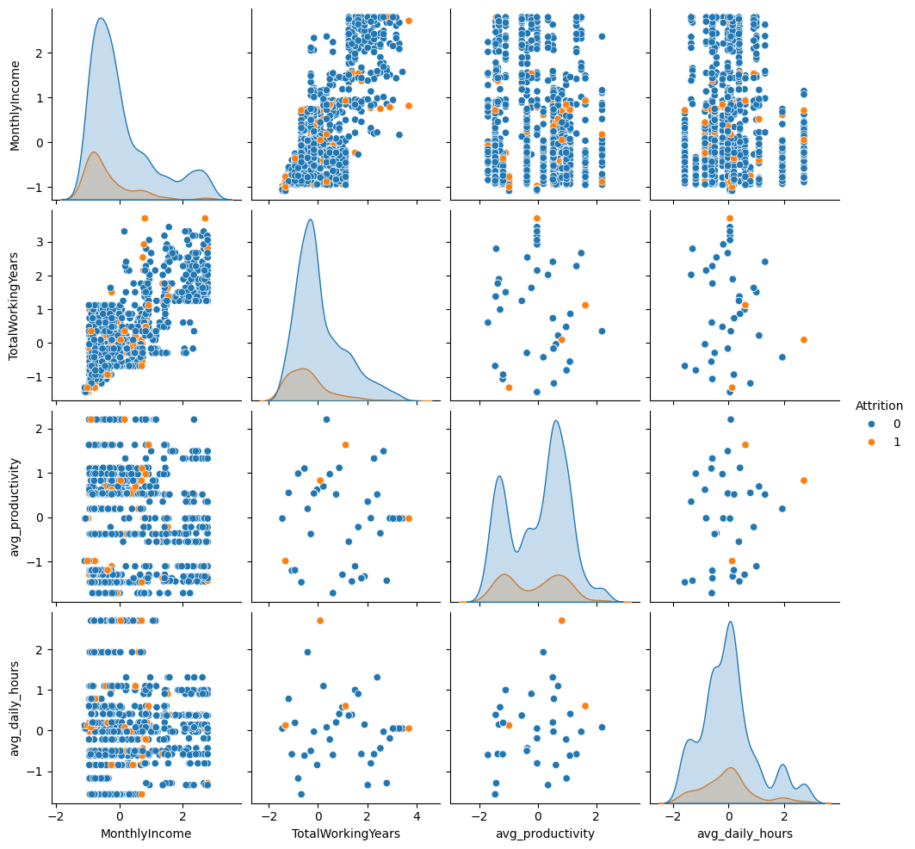Figure 4 Pairwise Relationships Among Monthly Income, Total Working Years, and Productivity Metrics by Attrition Status
The pairplot demonstrates moderate positive relationships between MonthlyIncome and TotalWorkingYears. Employees who left appear more concentrated in lower income and lower experience ranges, while productivity variables show overlapping distributions across attrition groups.
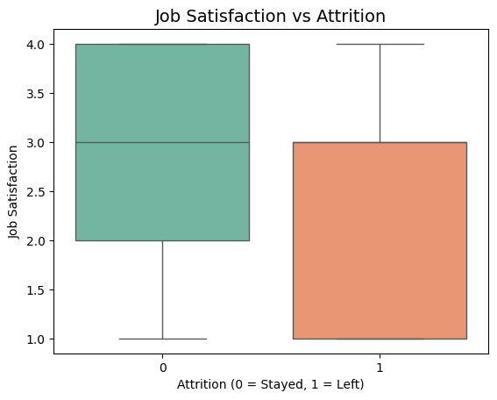
Figure 5 Job Satisfaction by Employee Attrition Status
Employees who left the company show lower job satisfaction compared to those who stayed. The median satisfaction level is higher among employees who remained, indicating that job satisfaction is an important factor related to employee attrition.
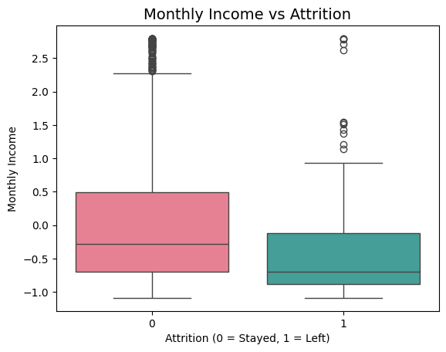
Figure 6 Monthly Income by Employee Attrition Status
Employees who left the company generally have lower monthly income compared to those who stayed. The median income for employees who remained is higher, indicating that income level is associated with employee attrition.
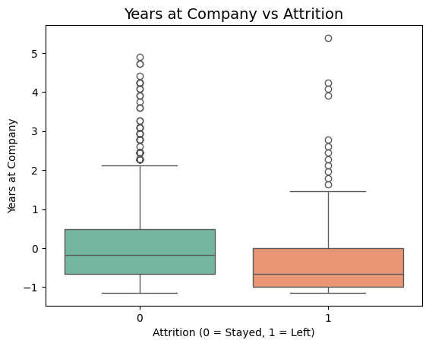
Figure 7 Years at Company by Employee Attrition Status
Employees who left the company generally have fewer years at the company compared to those who stayed. The median tenure is lower among employees who left, indicating that shorter company tenure is associated with higher employee attrition.
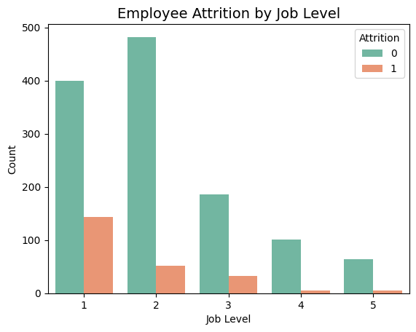
Figure 8 Employee Attrition by Job Level
Lower job levels, particularly Job Level 1 and 2, show higher numbers of attrition cases compared to higher job levels. As job level increases, the number of employees who leave decreases. This indicates that employees in lower level positions are more likely to leave the company than those in higher level roles.

5. Preliminary Findings
The exploratory analysis indicates that traditional HR variables remain strong indicators of employee attrition. Variables such as Job Satisfaction, Monthly Income, Years at Company, Job Level, and Overtime show noticeable relationships with attrition. Lower income, lower job level, shorter tenure, and overtime work are associated with higher attrition rates.
The aggregated productivity features show weaker direct relationships with attrition. While variables such as average productivity and daily work hours do not demonstrate strong individual correlations, they may still contribute useful information when combined with HR variables in a predictive model.
Furthermore, productivity metrics are highly correlated with each other, suggesting they capture similar behavioral patterns. However, their direct relationship with attrition appears limited compared to traditional workplace factors.

6. Plan for Completion
Team Responsibilities
The project tasks are divided to ensure balanced contribution and efficient progress.
Gurpreet Kaur
- Data cleaning and preprocessing
- Dataset integration and feature engineering
- Logistic Regression implementation
- Report writing and visualization preparation
Badamgarav Battushig
- Exploratory data analysis
- Random Forest implementation
- Model evaluation and comparison
- GitHub repository management
Shared Responsibilities
- Research design refinement
- Interpretation of results
- Final report preparation
- Presentation development

Remaining Data Tasks
The integrated modeling table has been constructed; however, final refinements will be completed before modeling. The experience-level aggregation approach will be reviewed to ensure consistent alignment between TotalWorkingYears and experience_years. Any redundant merging attempts will be streamlined to maintain a clear and reproducible integration pipeline.
Moreover, the class imbalance in the Attrition variable will be addressed. Since the dataset contains more employees who stayed than those who left, class weighting or resampling techniques will be applied to improve model fairness and predictive stability.

Modeling Plan
Two classification models will be implemented and compared:
Logistic Regression (Baseline Model)
Logistic Regression will be used as the primary baseline due to its interpretability and suitability for binary classification. This model will allow identification of significant predictors of attrition.
Random Forest (Comparison Model)
A Random Forest classifier will be implemented to capture potential nonlinear relationships and interactions between HR variables and productivity metrics. Feature importance scores will be extracted to evaluate the relative contribution of traditional HR factors versus aggregated productivity variables.

Evaluation Plan
The dataset will be divided using a standard train/test split. Cross-validation will be applied during model training to ensure generalization performance. Model performance will be evaluated using:
- Accuracy
- Precision
- Recall
- F1-score
- ROC-AUC
Due to class imbalance, particular attention will be given to Precision, Recall, F1-score, and ROC-AUC rather than relying solely on Accuracy.

Timeline

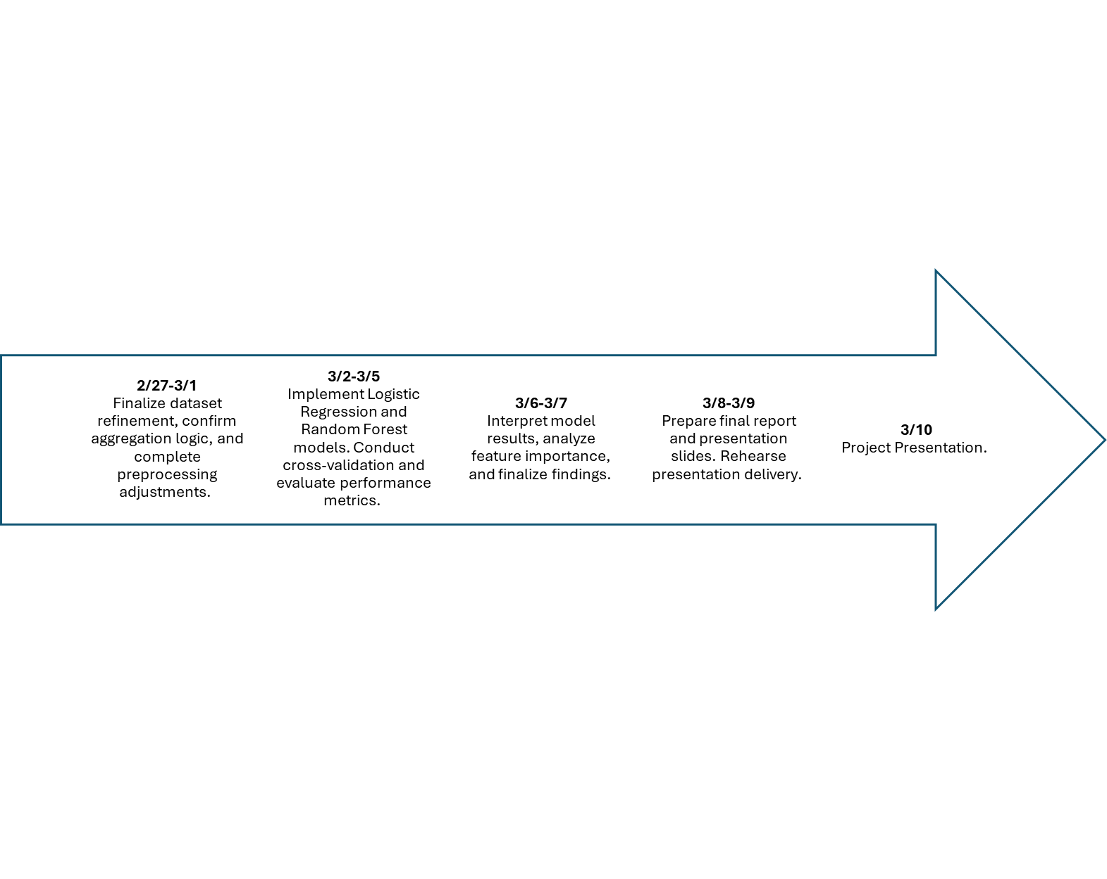

7. Git Repository
GitHub Repository Link:
https://github.com/Kaurgurpreet23/CPSC5071

8. References

Related work
Previous research shows that employee attrition is influenced by job satisfaction, compensation, workload, and career growth opportunities. Machine learning approaches such as Logistic Regression and Random Forest are commonly used for attrition prediction due to their interpretability and ability to capture nonlinear relationships.
Logistic Regression provides a baseline model for identifying statistically significant predictors of employee turnover, while Random Forest improves predictive performance by modeling complex interactions among workplace factors.
Recent studies also highlight the importance of behavioral and productivity metrics in understanding employee engagement, particularly in remote work environments. Incorporating productivity indicators alongside traditional HR variables allows for a more comprehensive attrition modeling framework.
Citations
- Breiman, L. (2001). Random forests. Machine Learning.
- Hosmer, Lemeshow & Sturdivant. Applied Logistic Regression.
- IBM HR Analytics attrition dataset research papers (commonly cited)
- TheDevastator. (n.d.). Employee attrition and factors. Kaggle.
https://www.kaggle.com/datasets/thedevastator/employee-attrition-and-factors
- Ziya07. (n.d.). Remote worker productivity dataset. Kaggle.
https://www.kaggle.com/datasets/ziya07/remote-worker-productivity-dataset

